SMART TIME TABLE GENERATOR
@CREATIVITY THINK (9483175986/7019689991)

ABSTRACT:
The Smart Time Table Generator is a web-based automation system designed to create optimized academic schedules for schools, colleges, and tutors. The platform enables users to input subjects, availability, teacher preferences, and custom rules to automatically generate conflict-free timetables. Integrated with a powerful conflict-checker and scheduling engine, the system ensures efficient allocation of subjects, time slots, and resources. It provides dashboards, analytics, export options, and management tools for both users and administrators. Built on Django and Django Rest Framework for backend intelligence and React for a responsive user interface, the system delivers accuracy, automation, and operational convenience in academic timetable management..

INTRODUCTION OF THE PROJECT:
Academic scheduling is a complex procedure that becomes increasingly challenging when involving multiple classes, subjects, teachers, and room constraints. Manual scheduling consumes time, often results in conflicts, and lacks flexibility for updates. The Smart Time Table Generator addresses these limitations by providing an automated digital platform capable of generating schedules instantly using predefined rules and availability criteria. Users can modify rules, regenerate schedules, and detect conflicts in real time. The system further supports dashboards, analytics, and exportable reports, ensuring comprehensive planning and efficient decision-making for educational institutions..

PROJECT OBJECTIVES:

• Provide an automated system to generate academic timetables
• Allow users to input subjects, teachers, availability, and constraints
• Automatically detect and eliminate scheduling conflicts
• Enable users to set custom rules for optimization
• Provide dashboards and statistics for user insights
• Allow administrators to manage rules, users, and schedules
• Support exporting timetables in PDF, Excel, and image formats
• Improve scheduling efficiency and accuracy through automation

PROBLEM OF THE STATEMENT:
Creating academic schedules manually is time-consuming, error-prone, and unsuitable for large educational environments. Inconsistent availability, overlapping sessions, and last-minute changes make manual processes unreliable and inflexible. Institutions lack tools that automate scheduling while supporting custom constraints and conflict detection. The Smart Time Table Generator solves these issues by providing automated generation, conflict resolution, rule-based optimization, and comprehensive schedule management, enabling institutions to save time and improve efficiency..

MOTIVATION OF THE PROJECT:
• To replace manual scheduling with automated timetable generation
• To minimize human errors and eliminate scheduling conflicts
• To support institutions with customizable rules and flexible scheduling
• To provide visual dashboards and analytics for better planning
• To improve productivity for teachers, administrators, and students
• To offer an easy-to-use digital system accessible across devices
• To simplify the process of exporting, updating, and managing schedules

BLOCK DAIGRAM OF PROJECT:

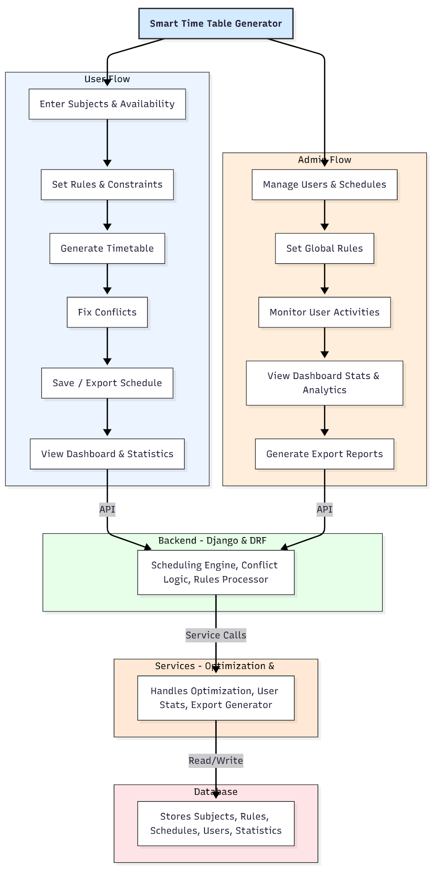

WORKING OF THE PROJECT:
The system begins when users input subjects, availability slots, and rule preferences. The backend’s scheduling engine processes all inputs, applies constraints, and generates optimized timetables. The conflict checker highlights overlapping sessions or invalid assignments, enabling users to fix conflicts or regenerate the schedule instantly. Once finalized, users can save, export, or share the timetable. Administrators supervise global rule settings, manage user activities, and monitor analytics from dashboards. The services module handles optimization, user statistics, and export processing, while the database stores all structured data including subjects, rules, schedules, and user interactions. This workflow ensures accuracy, automation, and flexibility in schedule creation..

SOFTWARE REQUIREMENT:
- Backend:
  - Python 3.x
  - Django
  - Django REST Framework
  - SQLite/PostgreSQL
- Frontend:
  - Node.js and npm
  - React.js
  - Axios
- Development Tools:
  - Visual Studio Code
  - Postman (for testing APIs)
  - Git/GitHub (for version control)
- Server/Deployment (Optional):
  - Gunicorn, Nginx, or Heroku/AWS for hosting

ADVANTAGES OF THE PROJECT:

• Fully automated timetable generation
• Conflict detection and resolution engine
• Custom rule-based scheduling
• Dashboard insights and analytics
• Reduced manual workload and human errors
• Multi-export options for sharing schedules
• Enhanced academic planning and resource utilization
• Scalable for any educational institution

APPLICATIONS OF THE PROJECT:
• Schools
• Colleges
• Coaching centers
• Private tutors
• Training institutes
• Any organization requiring structured scheduling

REFERENCES:

- Django REST Framework Documentation — Django Software Foundation. Django Documentation. Available: https://docs.djangoproject.com/
- Django REST Framework. DRF Documentation. Available: https://www.django-rest-framework.org/
- React. React Official Documentation. Available: https://reactjs.org/docs/getting-started.html
- Redux. Redux Documentation. Available: https://redux.js.org/introduction/getting-started
- PostgreSQL Global Development Group. PostgreSQL Documentation. Available: https://www.postgresql.org/docs/
- MySQL. MySQL Reference Manual. Available: https://dev.mysql.com/doc/
- Git. Git Documentation. Available: https://git-scm.com/doc
- Node.js. Node.js Documentation. Available: https://nodejs.org/en/docs/
- Axios. Axios Documentation. Available: https://axios-http.com/docs/intro
- Socket.io Documentation – https://socket.io/docs/

